BUSINESS PLAN

RiverBend Retailers Morris Hall
Minnesota State University, Mankato Mankato, MN 56001

TABLE OF CONTENTS

Executive Summary 3
Products 5
Flags 5
Wall Décor 6
Organizational Structure 7
Mission Statement 9
SWOT Analysis 10
Marketing 11
Objectives 11
Target Market 12
Demographic Market Research: 13
Data Collection Survey – One 13
Marketing Mix Strategy 16
Product strategy 16
Pricing strategy 17
Flags 17
Wall signs 17
Promotion Plan 18
Distribution strategy 20
Operational Strategy 21
Inventory Management 21
Cash Management 23
Financial Analysis 24
Revenue Forecast 24
Expected Case Scenario 25
Best Case Scenario 26
Worst Case Scenario 27
Balance Sheet 28
Breakeven Analysis 30
Ratio Analysis 31
Risk Analysis 32

EXECUTIVE SUMMARY

PROPOSED BUSINESS

RiverBend Retailers has been formed to design, source production, and distribute home décor items specific in nature to the Greater Mankato community.

MISSION

RiverBend Retailers strives to be the premier provider of home décor products in the Greater Mankato, Minnesota area that helps support and build pride for the community that many call their home. Through creative design and superior product quality, RiverBend Retailers will achieve this goal by creating a loyal customer base that is satisfied with the purchase of our products.

ORGANIZATIONAL STRUCTURE

RiverBend Retailers is an organization comprising of twenty-one individuals broken down from an executive board with four main departments. Top tier executive management consists of Chief Executive Officer Tariq Islam and Vice President, Nathaniel Tucek. The goal of top tier management is to provide guidance for the organization, ensuring a streamlined communication between departments and act as a liaison with outside partners. Base level executives consist of Chief Marketing Officer Nicholas Meyer, Chief Operations Officer Joel Lange, Chief Financial Officer Dylan Riess, and Chief Sales Officer Matthew Luke. Under each executive, comprises a team devoted to carrying out the specified tasks for each division.

MARKET
RiverBend Retailers plans to position themselves through product design to penetrate two prominent markets within the Greater Mankato community. The two key groups consist of students as well as the local population with middle class income.

OBJECTIVE

Through formation of RiverBend Retailers, the organization has set a goal to generate a revenue base enough to pay off the loan and turn a profit.

FUNDING

To enable RiverBend Retailers to source products and market these products, an initial cash investment of $2,300 is required.

PRODUCTS

We create unique home decorating products for residents of the Mankato community. The products RiverBend Retailers are offering include Minnesota State University, Mankato colored “Kato” themed flags and handcrafted wooden wall décor.

FLAGS
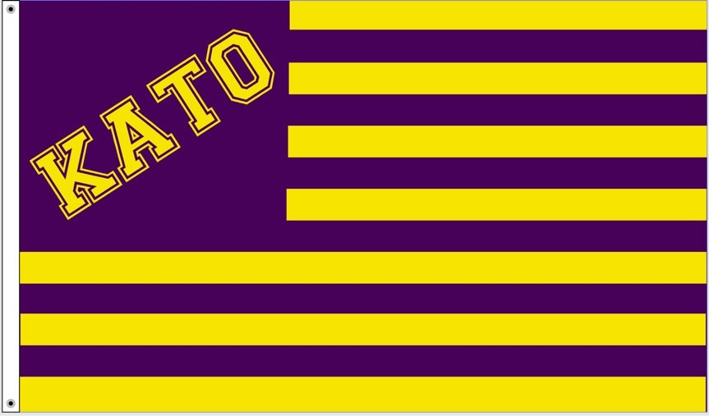
3ft x 5ft size

Printed directly to material – high resolution
Grommet for ease of use

WALL DÉCOR

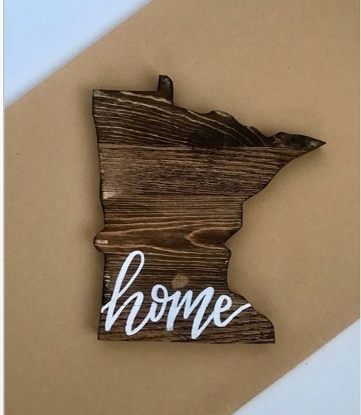
Size: 16in x 16in
Material: Oak
Production: Hand crafted by supplier

ORGANIZATIONAL STRUCTURE

Chief Executive Officer

Tariq Islam: President – Bangladesh Student Organization, VP Risk Management- Inter- Fraternity Council, Membership Chair- Phi Kappa Psi.

Vice President

Nathaniel Tucek: Marketing Assistant & Marketing Strategy consultant – South Central Minnesota Small Business Development Center, Advisory board member (marketing and strategy) – BizLink North

Executive Assistant:

Paige Blomberg: Personal Assistant- eWomenNetwork

Chief Finance Officer:

Dylan Riess: Vice President – Accounting Club, Community Advisor – Residential Life, Eagle Scout – Boy Scouts, Secretary – Student Ambassadors

Chief Sales Officer:

Matthew Luke: Culinary Sales Assistant- Wings & Rings

Chief Operations Officer:

Joel Lange: Lead Detailer-Unique Specialty and Classics, Assistant Manager- Dock1Bargains

Chief Marketing Officer:

Nicholas Myer: Vice President of Sigma Nu – Past Interviewer at Big Discovery Project

– P.R Marketing and Philanthropy Promotion Chairmen Sigma Nu.

Chief Executive Officer Tariq Islam
Executive Assistant Paige Blomberg

Vice President Nathaniel Tucek

Chief Marketing Officer Nicholas Myer

Chief Financial Officer Dylan Riess

Chief Sales Officer Matthew Luke

Chief Operating Officer Joel Lange

Marketing Committee Finance Committee

Operations Committee

Sales Committee

MISSION STATEMENT

“RiverBend Retailers strives to create a lasting impression within the residents of Mankato. We believe in putting smiles on the faces of the people within our community through providing quality products that represent their pride of being a part of the Minnesota culture”

SWOT ANALYSIS

Strengths | Weaknesses
- Mankato based company selling to a customer base that is local and familiar with the University  - Large customer base within the University  - Affordable and variety of products for our customers  - Unsaturated market | - Lack of experience  - Limited to build our brand  - Limited time to properly research our customer base  - Season makes it difficult to market or sell our products outside  - Part time employees
Opportunities | Threats
- Network and establish effective relationships with local businesses  - Large target market for our products  - Recent college culture  - Previous successful market venture | - Competing with Scheels, Kohl’s and the campus bookstore  - No real necessity of this product to a customer; purely decorative purpose

MARKETING

OBJECTIVES

- Reach 25,000 individuals for our company social media campaign

- Table at least 15 events throughout the 8-week sales period

- Connect with non-profits to further increase our target market and expand our brand name

TARGET MARKET

RiverBend Retailers’ primary target market will be focused on the community of Minnesota State University, Mankato and the surrounding community. This would include students and local businesses around town that have love and respect for the city and state they call home. Our secondary market will target Mankato residents, faculty/staff and alumni of the university.
The demographics we plan to reach include the 15,000 students and the local population. Many young adults who are interested in higher education coming out of high school are short on spending money which we are taking into consideration on prices we set. The products we offer can be purchased by any gender, which expands our target market and resonate with their lifestyles and behaviors. We plan to utilize social media to reach out to potential customers with platforms such as Facebook, Instagram, LinkedIn, Twitter and Snapchat.
Being a local company with many connections, our target markets consist of the students and the residents of Mankato. We have the advantage of making in-person sales by setting up tabling events in areas where highest frequency of interaction with target market will take place. According to the US Census Bureau, there are roughly 99,000 residents in the Mankato Metro Area, thus giving us a large market to introduce our products to.
According to our survey, we have a market we can appeal to that has potentially high-demand for our products. We also have an advantage above our competitors by not limiting ourselves to one specific market. We attract both male and female college students, residents, and local

businesses within the community. With this data, we are confident that we will achieve our revenue goal.

DEMOGRAPHIC MARKET RESEARCH:

DATA COLLECTION SURVEY – ONE

Which gender do you identify yourself as?

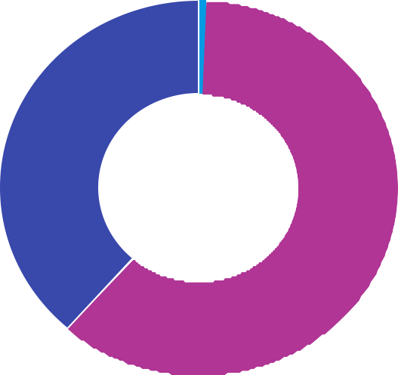
- Male 187
0.62%
38.56%
60.82%
- Female 295
- N/A 3
- Total 485

N/A Female Male

What is your age?

- 17 or under 12

- 18-22 300

- 23-30 71

- 31+ 102

- Total 485

2.47%
21.03%
14.64%
61.86%

31+ 23-30 18-22 17 or under

Do you currently attend Minnesota State University, Mankato?

➢ | Yes | 264
➢ | No | 221
Total |  | 485

45.57%
54.43%

No
Yes

MARKETING MIX STRATEGY

PRODUCT STRATEGY:

We create unique home decorating products for residents of the Mankato community. The products RiverBend Retailers are offering include Minnesota State University, Mankato colored “Kato” themed flags and handcrafted wooden wall décor. We will build our brand through the use of our logo on social media.

PRICING STRATEGY

FLAGS

The initial selling price will be $20. If weekly sales are not met, we will discount the price starting in Week 6 of operations. The first discount will be a reduction of $5. Further discounts will be evaluated as required.

WALL SIGNS

The initial selling price will be $50. If weekly sales are not met, we will discount the price starting in Week 6 of operations. The first discount will be a reduction of $5. Further discounts will be evaluated as required.
.

PROMOTION PLAN

Our team wants to promote our products by word of mouth as much as possible. Our promotional strategies include platforms like social media, setting up tables in the Centennial Student Union along with the University Dining Center, creating promotional flyers, and taking advantage of free advertisement through the partnership with our charity. Our company would like to build a strong social media presence with our focus on Instagram, Facebook and LinkedIn. We would like to fill our Instagram page with high-resolution photos of our products. All our products will be promoted and marketed on these social media platforms. We plan to use social media platforms to their fullest potential by boosting posts to increase engagements with the target market. We believe social media will play a key role in marketing our products and reaching an audience off-campus. With two posts a week on both Instagram and Facebook, it will promote our product by always having it in front of the consumers’ eyes.
- Facebook https://www.facebook.com/riverbendretailers/
- Instagram https://www.instagram.com/riverbendretailers/
- LinkedIn https://www.linkedin.com/company/riverbend-retailers/

PROMOTIONAL PLAN SCHEDULE

 | Week 1 | Week 2 | Week 3 | Week 4 | Week 5 | Week 6 | Week 7 | Week 8 | Total
Social Media | 6 Posts on both Facebook and Instagram | 2 Posts on both Facebook and Instagram | 2 Posts on both Facebook and Instagram | 2 Posts on both Facebook and Instagram | 2 Posts on both Facebook and Instagram | 2 Posts on both Facebook and Instagram | 2 Posts on both Facebook and Instagram | 2 Posts on both Facebook and Instagram | 20
Promotion | 1 Tabling event in CSU | 2 Tabling events in CSU | 2 Tabling events in CSU | 2 Tabling events in CSU | 2 Tabling events in CSU | 2 Tabling events in CSU | 2 Tabling events in CSU | 2 Tabling events in CSU | 15
P.R  Community based marketing | 1 event at the boys and girls club | 1 church presentation | 1 church presentation | 1 church presentation | 1 church presentation | 1 church presentation | 1 church presentation | 1 church presentation | 8

DISTRIBUTION STRATEGY

Our company will deliver directly to our customers by advertising sale locations and tabling events around the local community. Our distribution will be from our inventory location located on-campus. Many of our targeted audience will be students on campus and our tabling events will put our products in front of them twice weekly. Our primary sales location will be on campus which is the perfect location to make customer connections with our target market. The dates we will be tabling in the CSU are as follows:

  - March 12

  - March 21

  - March 26

  - March 28

  - April 2

  - April 4

  - April 9
  - April 11

  - April 16

  - April 18

  - April 23

  - April 25

  - April 30

  - May 2

**All dates above are every Tuesday and Thursday from 10 am – 2 pm in the Centennial Student Union on campus**

OPERATIONAL STRATEGY

INVENTORY MANAGEMENT

The inventory will be kept inside a spare office within the Center of Innovation and Entrepreneurship (CIE) in downtown Mankato. The location will be locked. One key will be shared between inventory managers Joel Lange and Taya Sexton. The other key be held by Dr. Yvonne Cariveau, the director of the CIE. Vice President Nate Tucek will also have access to the product as he works in CIE. Joel and Taya will coordinate with other students to distribute product to them. There will be a log inside the room where the quantity and value of the product will be recorded along with the person that took the inventory. A member(s) of the operations committee will transport and distribute the inventory to other company members. We will need their car insurance information and likely a photocopy of their valid driver's license. The members of the company will be able to coordinate with Joel or Taya to pick-up the product from the CIE. All flags and wood signs will be thoroughly checked for any defects upon arrival. Products with any defects would not be sold. We will not be exposed to liability with our customers through this process. All items will be inspected before they are available to be purchased using our inventory control system. When shipments arrive, multiple members will unbox, count, and check the items for any defects. There is no return or exchange policy for our products. With our thorough inspection system upon arrival there will be no defective products available for sale. If sales are less than forecasted, we will discount the products. Shipping will be done case by case basis and will not be advertised. The customer will make payment for

shipping cost if needed. When the products arrive, operations committee will create a real-time quote of shipping prices by contacting the postal services.

CASH MANAGEMENT

A cash management excel sheet will be created for recording cash transactions. Cash withdrawn, cash “in hand” and cash deposited will be observed on this sheet weekly. It will be similar to the inventory sheet so that information can be easily transferred between both. The designated cash managers will control the cash flow statement. Cash tendered will be logged on recipients in order to aid the cash managers. Within the document, we will log the sellers who have taken out product and how much they have taken along with the value of the product. Once the products are sold, the seller will give the money to one of the designated cash managers. The cash managers will count the money and make sure it matches the amount on the inventory log before money gets deposited. There will be weekly deposits unless the value reaches $350, where it will be deposited immediately. Receipts will be kept for deposits and brought to class as soon as we receive them. The receipts will be given to the accountant, who will reconcile the deposit based on the amount of cash sales for the week. We will get card readers for the sales people to take with them. In the notes section, they will record their name, the customer’s name and specify that it was an electronic sale on the receipt. When they make the sale, they will fill out our receipt form within excel. This receipt will include the seller’s name and the customer's name. Then it will be given to the accountant, where they will be paired together.

FINANCIAL ANALYSIS:

REVENUE FORECAST

As the revenues and expenses were assembled for RiverBend Retailers, three different scenarios were considered: the expected case, best case, and worst-case scenarios.

Money Earned After Loan

Repayment
Expected Case Scenario | $4,476.64
Best Case Scenario | $4,753.60
Worst Case Scenario | $4,274.36

EXPECTED CASE SCENARIO

The first week of the scenario has no revenues while the merchandise is shipped but come week 2 it will have arrived and should be getting sold. The sales will start off strong and are expected to slow down closer to the end of the period.
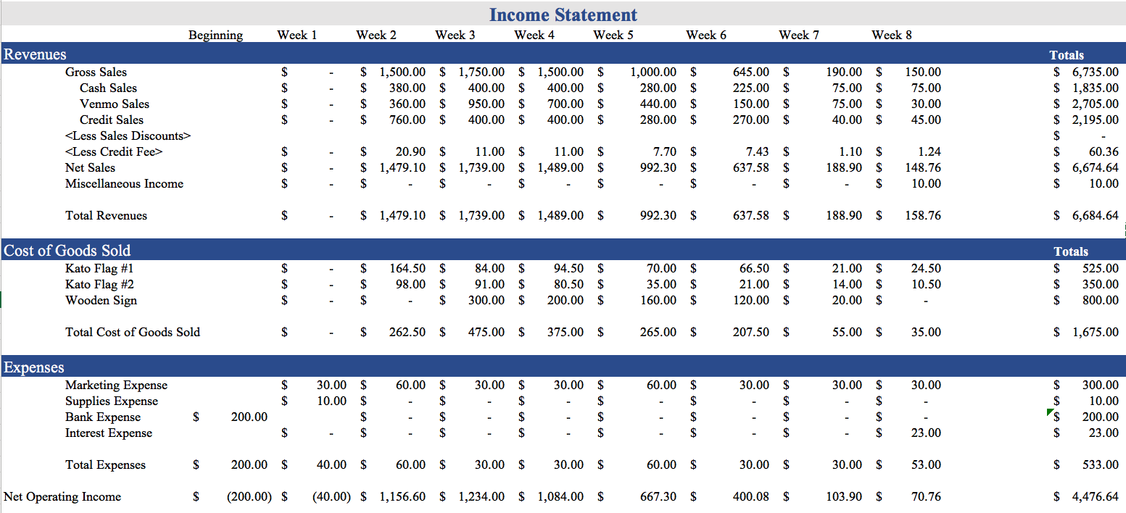

BEST CASE SCENARIO

In the best-case scenario for RiverBend Retailers, sales start out very strong and continue strong throughout the entire selling period.
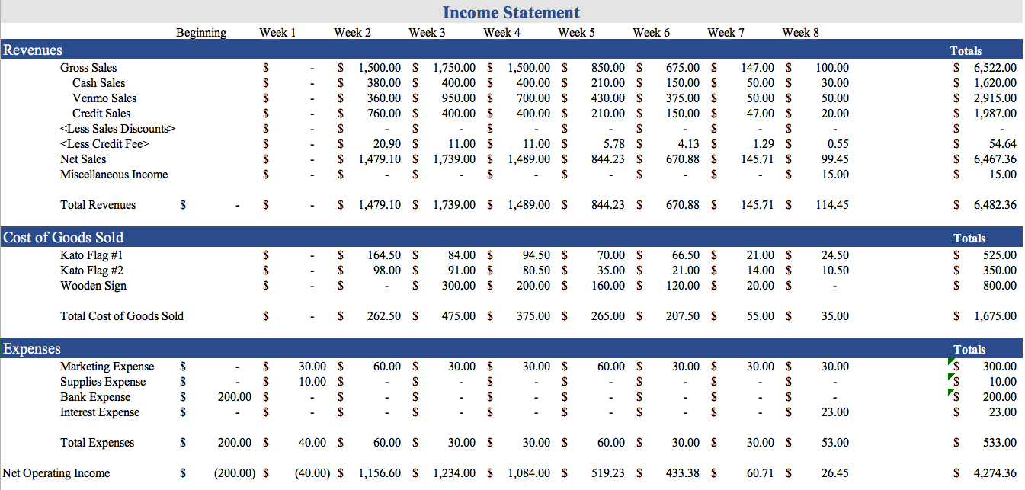

WORST CASE SCENARIO

The worst-case scenario has tighter profit margins due to product discounts being incorporated into the price in Week 6. However, there is still a fair amount of Net Income earned.

BALANCE SHEET

The predicted balance sheet for RiverBend Retailers was considered for three different scenarios: the expected case, best case, and worst case.

EXPECTED CASE

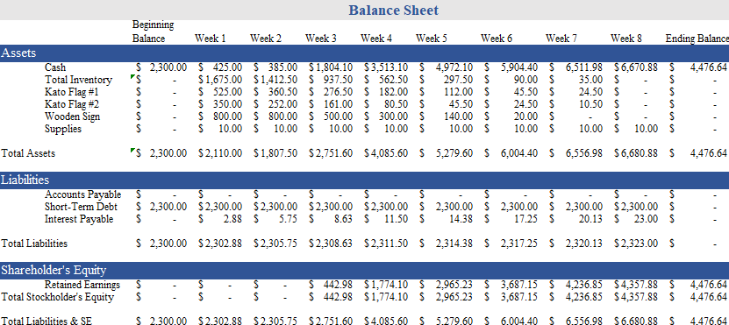

BEST CASE SCENARIO

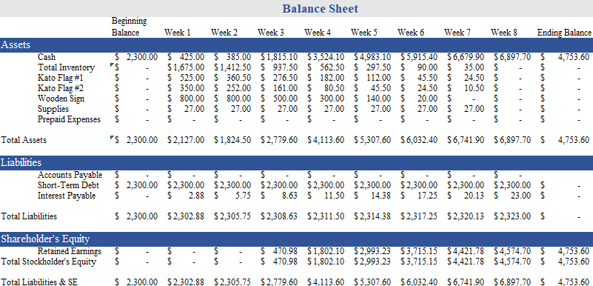

WORST CASE SCENARIO

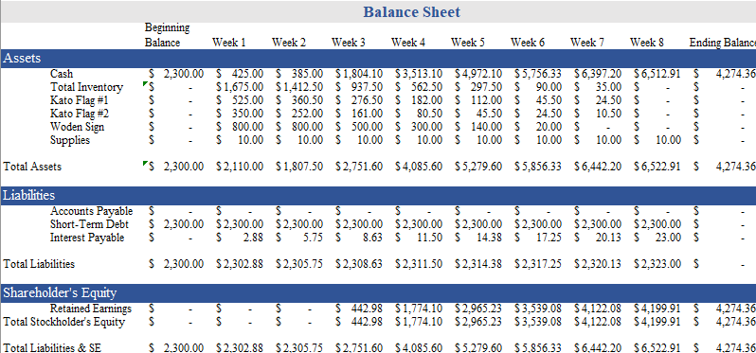

BREAKEVEN ANALYSIS

To make sure that RiverBend Retailers will make a profit when it sells its projects, the breakeven point was calculated for three different predicted scenarios: the expected case, best case, and worst case. This number is the amount for each product that must be sold to recover fixed costs and variable product costs. For all three scenarios, 250 flags and 40 wooden signs were purchased by the company.
To hit the breakeven point during the sales process, the company must sell a certain amount of each product each week to hit that point. For the expected case scenario, RiverBend Retailers must sell 6 or 7 flags and 4 signs a week. For the best-case scenario, a minimum weekly sale of 6 or 7 flags and 4 signs must be met. In the case of the worst scenario, at least 8 flags and 4 or 5 signs must be sold weekly.

Number of Product Sold to hit Breakeven Point
 | Projected Case | Best Case | Worst Case
Flags | 57 | 57 | 75
Wooden Sign | 23 | 21 | 26

RATIO ANALYSIS

Throughout the lifetime of the business RiverBend Retailers, different parts of the income statement and balance sheet are compared to each other as ratios. Two of the more prominent ratios are the current ratio and the debt service coverage ratio. The current ratio is found by dividing current assets by current liabilities. The most important ratio, the debt service coverage ratio, is calculated by taking cash divided by loans and interest. This ratio helps show a company’s profitability from a loan. The Debt Service Ratio shows that at the end of doing business, RiverBend Retailers will have almost double the amount needed to repay the initial loan plus interest.
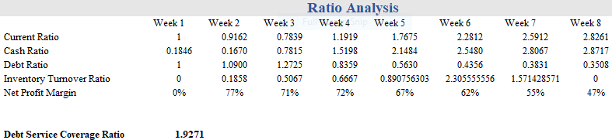

RISK ANALYSIS

In order to be fully prepared for all of the potential risks and threats to the company and our sales, we must be able to have foresight and plan for those risks, as well as taking measures to be able to avoid or solve them.
The first threat RiverBend Retailers may face as a company is that a majority of us are primarily inexperienced. Most of us do not have the experience of starting up or running a business, so we will be working together to learn how to do everything and get it done in a timely matter. In order to solve this problem, many of the company members have met up together multiple times outside of class and formed bonds with each other. These strong bonds help us to easily lean on one another for knowledge and skills, and will help us with any problems we may run into throughout the period we are doing business.
Another threat the company may face is receiving product not up to company standards. If we were to receive low-quality products, we would have to first decide how to satisfy the customers’ requests without having them wait too long while we exchange the merchandise. RiverBend Retailers will go through the steps to make sure we have a product we can fully back and will fully satisfy our customers.
The next threat that may hit RiverBend Retailers is the chance that our product may not appeal to consumers. The Marketing Department has collected a survey and used the results to find what would sell best to our target market. They have also built social media pages and created methods of advertising to get directly to the students at Minnesota State University, Mankato.

Another threat that is presented to RiverBend Retailers is the risk of catastrophe while storing our products. To mitigate this, the product will be stored in two separate locations:
- Center for Innovation & Entrepreneurship, Mankato, MN 56001
- IBE Kiosk, Morris Hall, Minnesota State University, Mankato, MN 56001
Sufficient amounts of each product will be kept in both locations in case one facility is subject to catastrophe and all products within are lost. That way, we will always ensure the breakeven point is reached.
The last issue that RiverBend Retailers may hit as a company is the issue of our product not selling. If this happens, we will discount the flags and wall decor to a cheaper price to sell better. Another option to fix this issue would be to bundle the products together, selling them at a cheaper price than it would take to buy them separately. This will encourage customers to buy both of our products and help boost our sales if they are down.

